|  |  |  |
| --- | --- | --- |
| Web Development 1000 | 2021-JULY | Assignment 4 |

**Task:** Go to W3Schools.com and complete the exercises below. Take a screen shot and paste them in this document. Each screen shot must have the following line in the code immediately after the line <head>

<title> YOUR NAME </title>

That is IF the screenshot has code in it.

If NOT, use snip and sketch to put your initials on the screen capture like so;

**Learning outcome evaluated:**

|  |  |  |  |
| --- | --- | --- | --- |
| 2 | Based on web standards, author web pages using HTML/CSS with a text editor. | | |
|  |  | 2.1 | Create an HTML document without a WYSIWYG HTML editor. |
|  |  | 2.2 | Insert and use HTML tags, graphics, and special characters. |
|  |  | 2.3 | Create a variety of hyperlink types. |
|  |  | 2.4 | Use absolute and relative path names. |
|  |  |  |  |
|  |  |  |  |
|  |  |  |  |

**Instructions:**

First using W3School (W3S), read through the sections Comments through and including Images. Do the “Try it Yourself” tasks.

Once you have done the tasks in W3Schools creating a new web page using Visual Studio Code and include the following elements/features.

Use each of these at least twice:

* **Colour Good**
* **Fonts good**
* **Sizes**
* **Border**
* **Padding**
* **Margin**
* **Images Good**
* **Links, one absolute & one relative Good**
* **Links to each of the pages you have created so far this week so you can navigate between the pages with ease! Good**

And be sure to comment your code thoroughly!

Take a screenshot of your Webpage and put it here (Screen Shot 1)

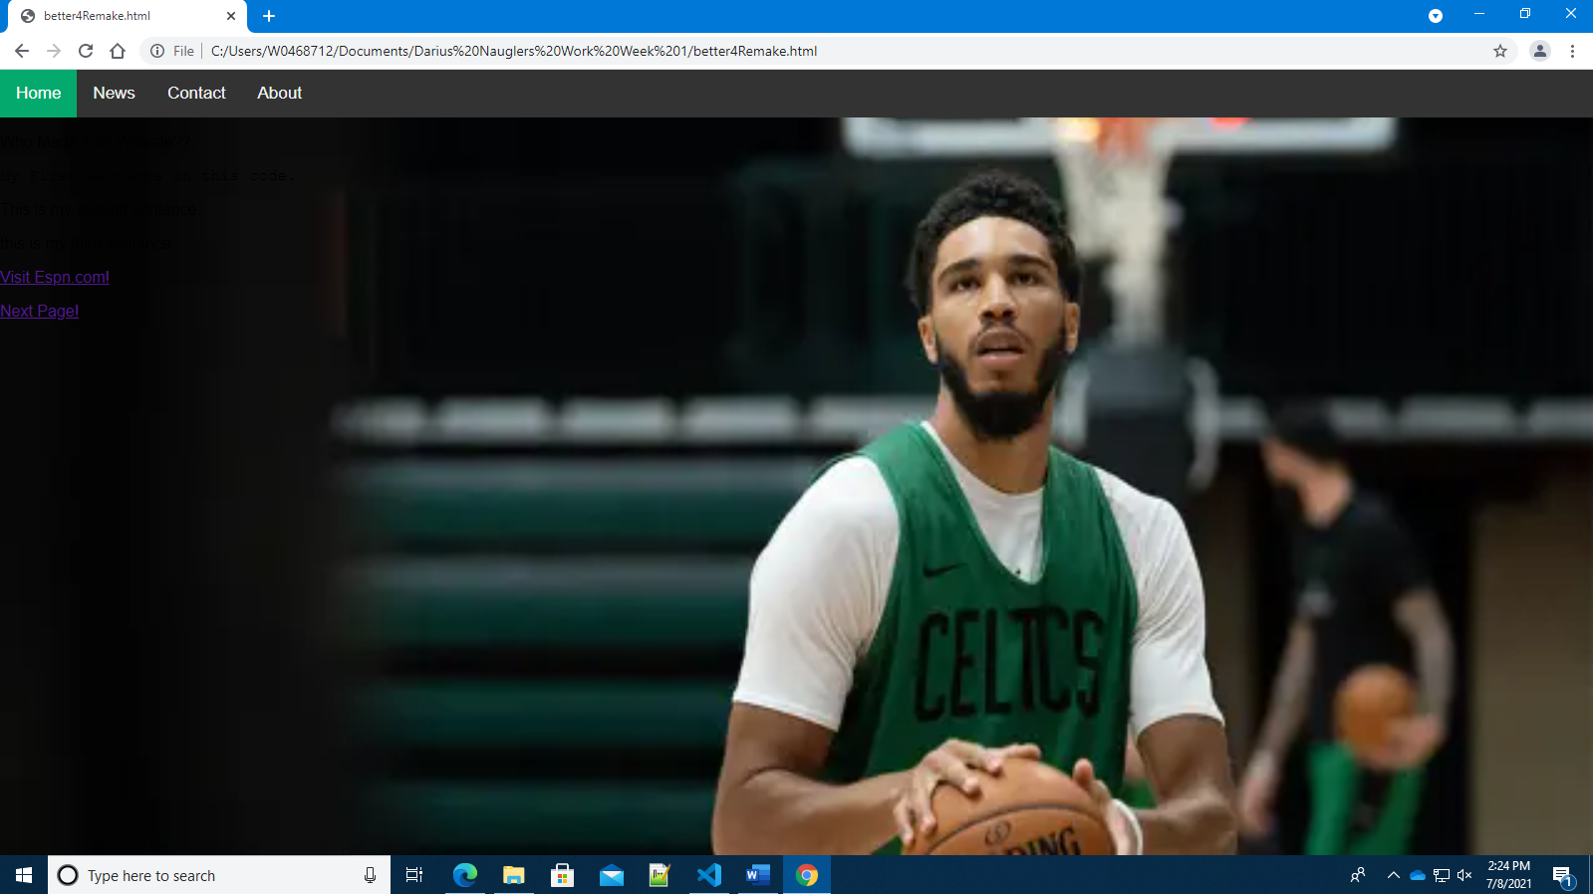

Place your CODE here (Code Submission) 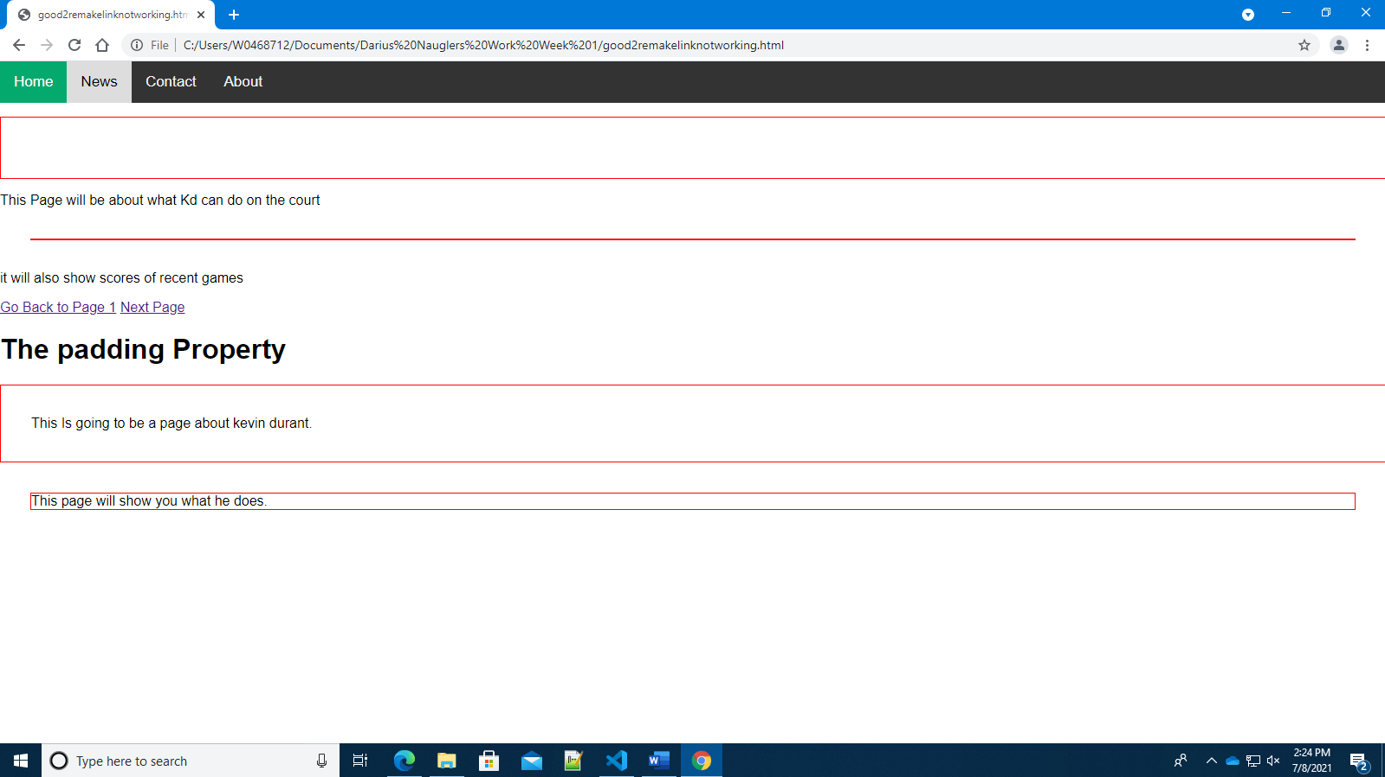

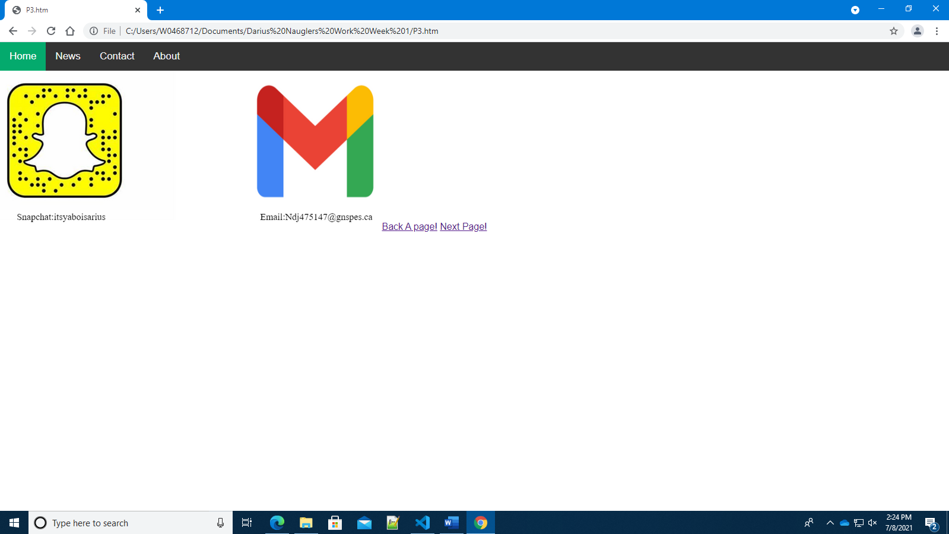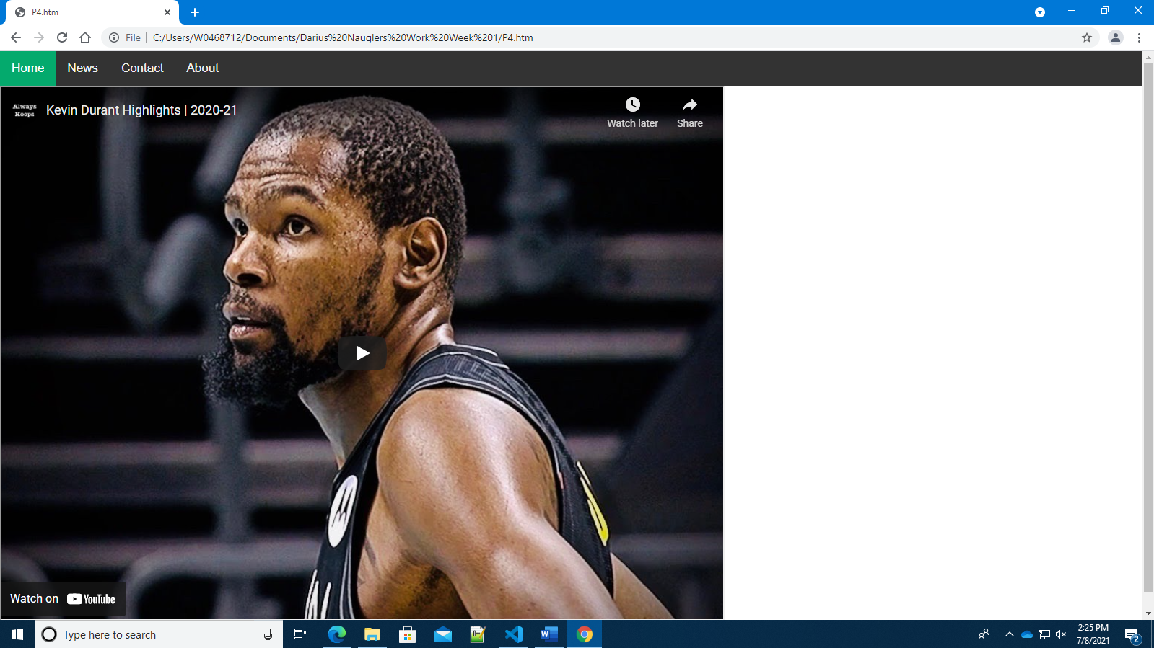

**Peer Discussion:** Once everyone has completed the W3Schools part of the assignment the class will be divided into groups of two or three. Students will discuss their findings and get feedback on their initial work. You will then continue with the Visual Studio Code part of the assignment. Give constructive criticism and help each other out! You can do this as a group but must each INDIVIDUALLY add the components to your code.

Be ready to talk about the components you have included!

**Notes:**

Make sure the screen captures are clearly visible and show what was asked for in the assignment.

When you capture a web page the URL must be clearly visible!